# Selling

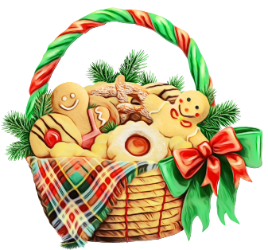

*You successfully started your cooking journey, so now you need to sell the products from your basket in the bakery in order to collect your price.*

You will be given an integer **n** for the **size** of the bakery with **square** shape. On the next **n** lines, you will receive the **rows** of the bakery. You will be placed on a **random position**, marked with the letter '**S**'. On random positions there will be clients, marked with a **single digit**. There **may** also be **pillars**. Their **count** will be either **0** or **2** and they are **marked** with the **letter** - '**O**'. **All of the empty positions** will be marked with **'-'**.

Each turn, you will be given **commands** for the **your movement**. Move commands will be: "**up**", "**down**", "**left**", "**right**". If you **move** to a **client**, you **collects** **the price** **equal** to the **digit** **there** and the client **disappears**. If you move to a **pillar**, you move on the **position** of the **other pillar** and then **both** pillars **disappear**. If you **go** **out** of the bakery, you **disappear** from the bakery and you are out of there. You need **at least** **50 dollars** to rent your own Bakery

When **you are out of the bakery or you collect enough money,** the program **ends**.

### Input

* On the first line, you are given the integer **n** – the size of the **square** matrix.
* The **next n lines** holds the values for every **row**.
* On each of the next lines you will get a move command.

### Output

* On the first line:
  + If the player goes to the void, print: "**Bad news, you are out of the bakery.**"
  + If the player collects enough star power, print: "**Good news! You succeeded in collecting enough money!**"
* On the second line print all star power collected: "**Money: {money}**"
* In the end print the matrix.

### Constraints

* The size of the **square** matrix will be between **[2…10].**
* There will **always** be **0** or **2** pillars, marked with the **letter** - '**O**'.
* Your position will be marked with '**S**'.
* You will **always** go out of the bakery or collect enough money.

### Examples

|  |  |  |
| --- | --- | --- |
| **Input** | **Output** | **Comments** |
| 5  SO---  -----  -----  -----  ----O  right  right | Bad news, you are out of the bakery.  Money: 0  -----  -----  -----  -----  ----- | The first command is right. You move to **one of the pillars** and then **appears** on the other side of it (4,4).  The bakery looks like this after the first command:  -----  -----  -----  -----  ----S  The second command is right. You go of the bakery. |
| 6  S98---  99----  666666  ------  --77--  -6-6-6  right  right  down  left  left  down  right  right | Good news! You succeeded in collecting enough money!  Money: 53  ------  ------  --S666  ------  --77--  -6-6-6 | Here we have **no** pillars and bakery rich of clients.  You manage to collect **enough** money **without** **going out** of the bakery.  The clients you have selled food to have disappeared and we can see where you were when you collected the last neeeded money (2,2). |